SOLID PRINCIPLES:

LINKS:
https://medium.com/codex/programming-principles-they-dont-teach-you-in-school-7c14b21cdf64

Single Responsibility

I’m full stack developer -> Violated.
I’m frontend developer -> Accepted
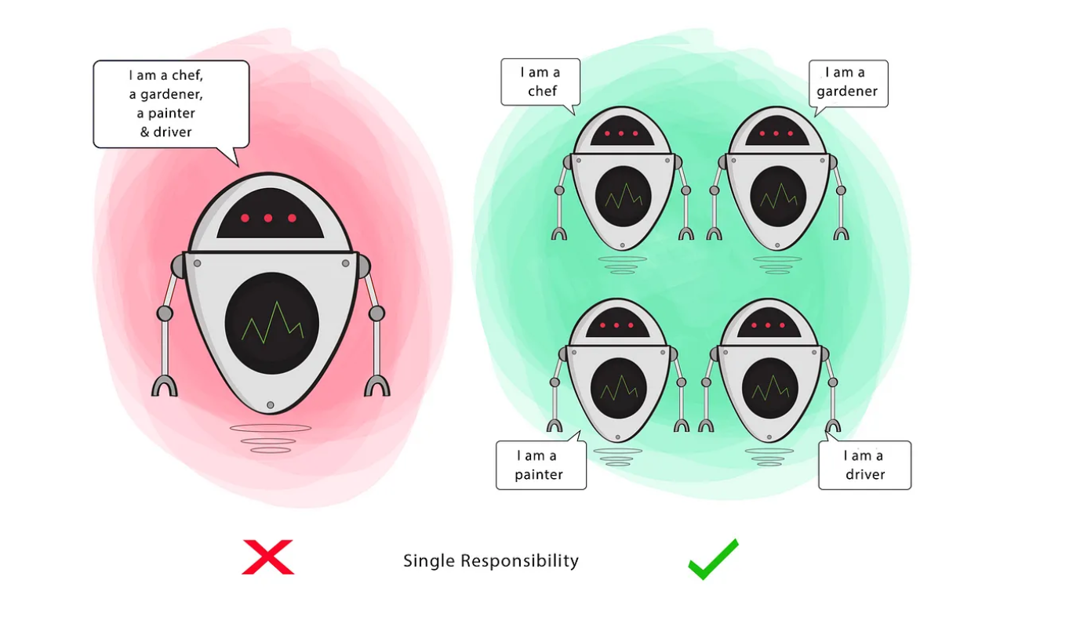

O — Open-Closed
Classes should be open for extension, but closed for modification

Changing the current behaviour of a Class will affect all the systems using that Class.
If you want the Class to perform more functions, the ideal approach is to add to the functions that already exist NOT change them.
Goal
This principle aims to extend a Class’s behaviour without changing the existing behaviour of that Class. This is to avoid causing bugs wherever the Class is being used.
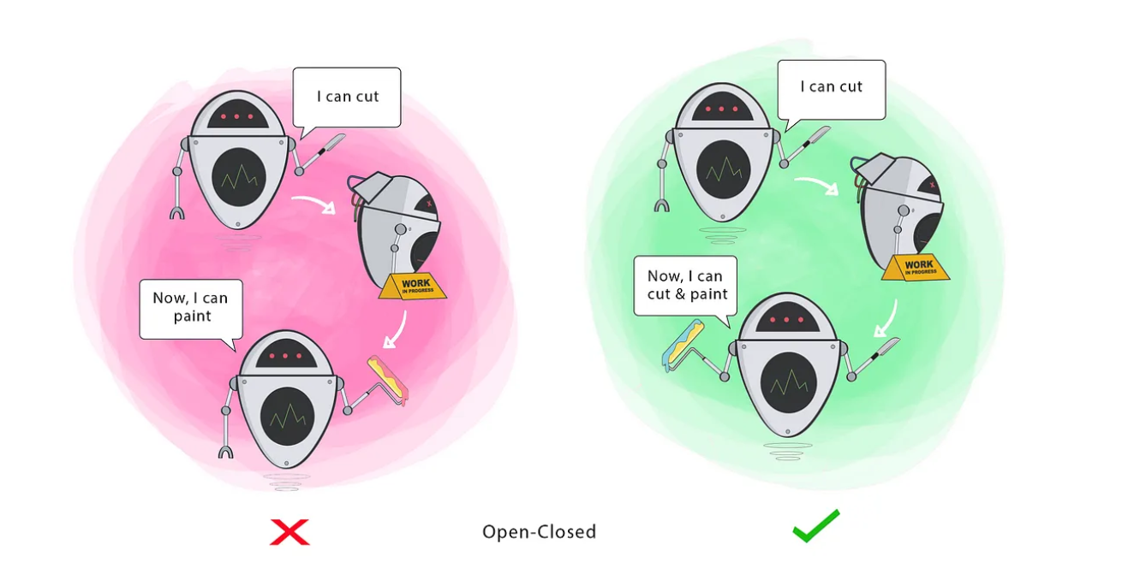

L — Liskov Substitution
If S is a subtype of T, then objects of type T in a program may be replaced with objects of type S without altering any of the desirable properties of that program.

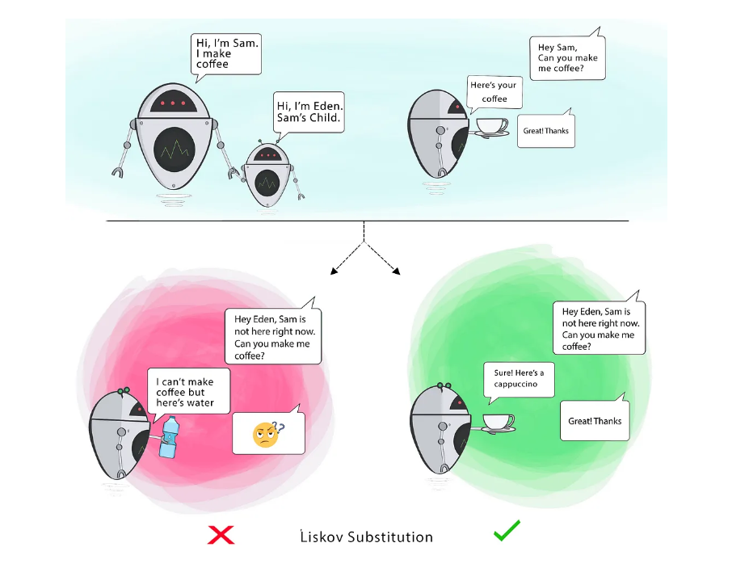

When a child Class cannot perform the same actions as its parent Class, this can cause bugs.
If you have a Class and create another Class from it, it becomes a parent and the new Class becomes a child. The child Class should be able to do everything the parent Class can do. This process is called Inheritance.
The child Class should be able to process the same requests and deliver the same result as the parent Class or it could deliver a result that is of the same type.
The picture shows that the parent Class delivers Coffee(it could be any type of coffee). It is acceptable for the child Class to deliver Cappucino because it is a specific type of Coffee, but it is NOT acceptable to deliver Water.
If the child Class doesn’t meet these requirements, it means the child Class is changed completely and violates this principle.

— Interface Segregation
Clients should not be forced to depend on methods that they do not use.

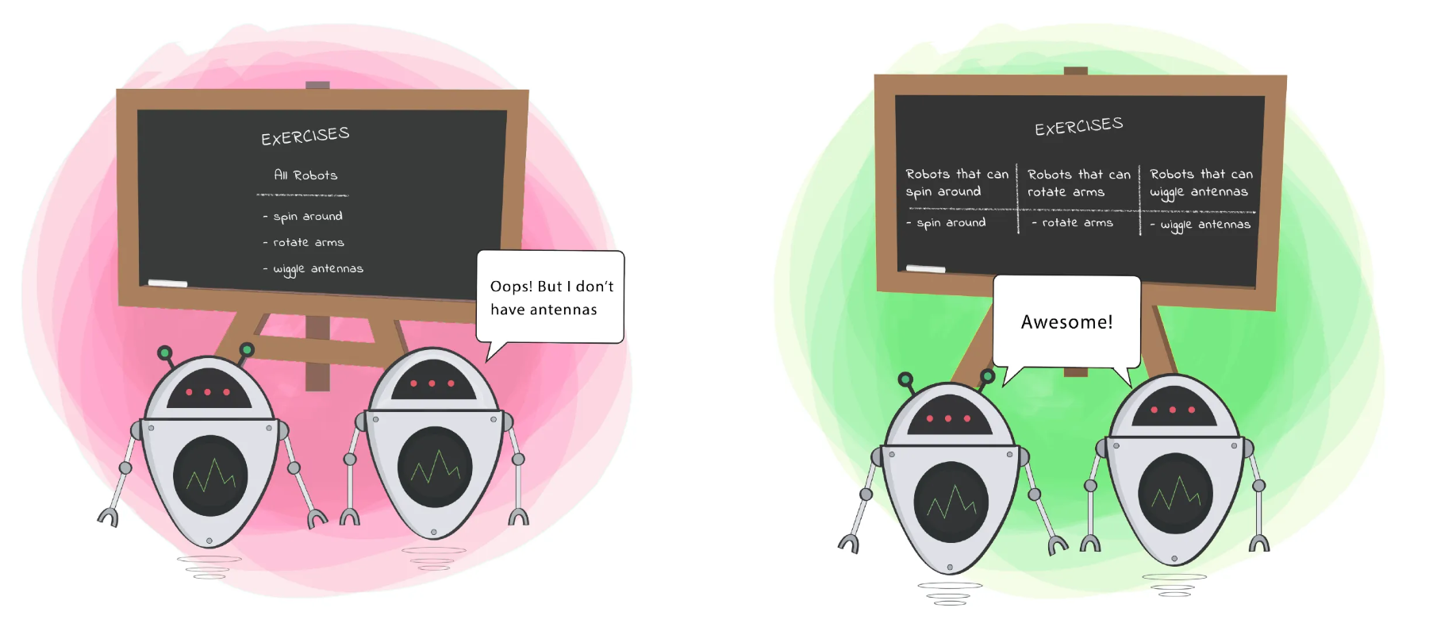

D — Dependency Inversion
- High-level modules should not depend on low-level modules. Both should depend on the abstraction.
- Abstractions should not depend on details. Details should depend on abstractions.

Like, I’m software engineer I should not depend on certain framework, I should be comfortable with any tool
